Manual Scavenging in India: A Skills Training and Employment Services Approach

*PPOL 768: Saloni Bhatia, Alexa Coon, Serenity Fan*

*Updated: May 8th, 2023*

**Introduction**

Manual scavenging involves the human collection and disposal of human excreta from dry latrines, railway tracks, septic tanks, sewer/drainage systems, and other sources without access to personal protective equipment, adequate social protection nor government support. The practice of manual scavenging is deeply entrenched in the caste system in India. Negative implications of this practice include social stigma associated with communities forced to perform “dirty work”, health implications of coming in direct contact with human waste, economic implications of earning the bare minimum for survival needs, and the human rights implications of undignified work conditions and societal marginalization. In essence, the problem of manual scavenging in India is a major governance and market failure to improve sanitation in the country, given years of continual failed interventions, promises, and stasis.

Over the years, many schemes and initiatives have been undertaken that should have improved the situation and made India open defecation free. However, the functioning, utility and behavior change that need to occur alongside proposed government interventions have gone unchecked and unreported. Consequently, generations of manual scavengers continue the forced labor of cleaning excreta in sewers despite several technological and scientific advancements that should have made manual scavenging less labor-intensive.

**Motivation**

During the pandemic, the government imposed nationwide lockdowns and curfews, the private sector implemented social-distancing and remote work policies, and hand-washing techniques took over the media. However, a forgotten section of frontline workers -sanitation workers- with poor access to safe water, decent sanitation and good hygiene (WASH) facilities continued to labor under hazardous working conditions and lack of government support.

In 1993 and 2013, the practice of manual scavenging was outlawed by the Indian government. Even after a 30-year long ban, the practice continues unabated. As per 2021 estimates by the Ministry of Social Justice and Empowerment, there are 58,098 manual scavengers in India (Ministry of Social Justice and Empowerment, 2021). The numbers may be an underestimation of reality as the majority of them belong to the socially marginalized sections of the Indian caste system known as the Dalits. While it would be imperative to consider the cultural sensitivity of the manual scavenging issue, and might require an assessment of the caste system responsible for marginalization of the community, we limit our study to behavior change at the individual and community level.

The research and knowledge implications of the proposed study is to understand the nuances of the failure to improve sanitation in India. The study provides an opportunity to reflect back on the past commitments and interventions by the government, in order to identify the reasons for failure and the absence of change in status quo.

**Target Population Characteristics**

Based on a baseline survey (WaterAid, 2020) conducted in 2018 in four states of India; Bihar, Madhya Pradesh, Uttar Pradesh, and Jharkhand, the key summary statistics have been shown in the figures below. There are primarily six forms of manual scavenging including cleaning of dry latrines, open drains, septic tanks, sewers, railway tracks and open defecation. Out of the 1686 manual scavengers that were surveyed in 2018, majority of the women were found to engage in cleaning dry latrines, as compared to men engaged in cleaning of septic tanks/pits. Out of 965 scavengers engaged in cleaning dry latrines, 57% had received no schooling. When asked if they already had skills for alternate, dignified livelihoods, women surveyed mentioned: construction laborer (33), livestock rearing (134), cook (389), beautician (37), tailor (53), and midwifery (29) as the employment fields of their choice. Even though the scope of the study is limited to only four states, the factual representation of manual scavengers in the report adds to our understanding of the target population.

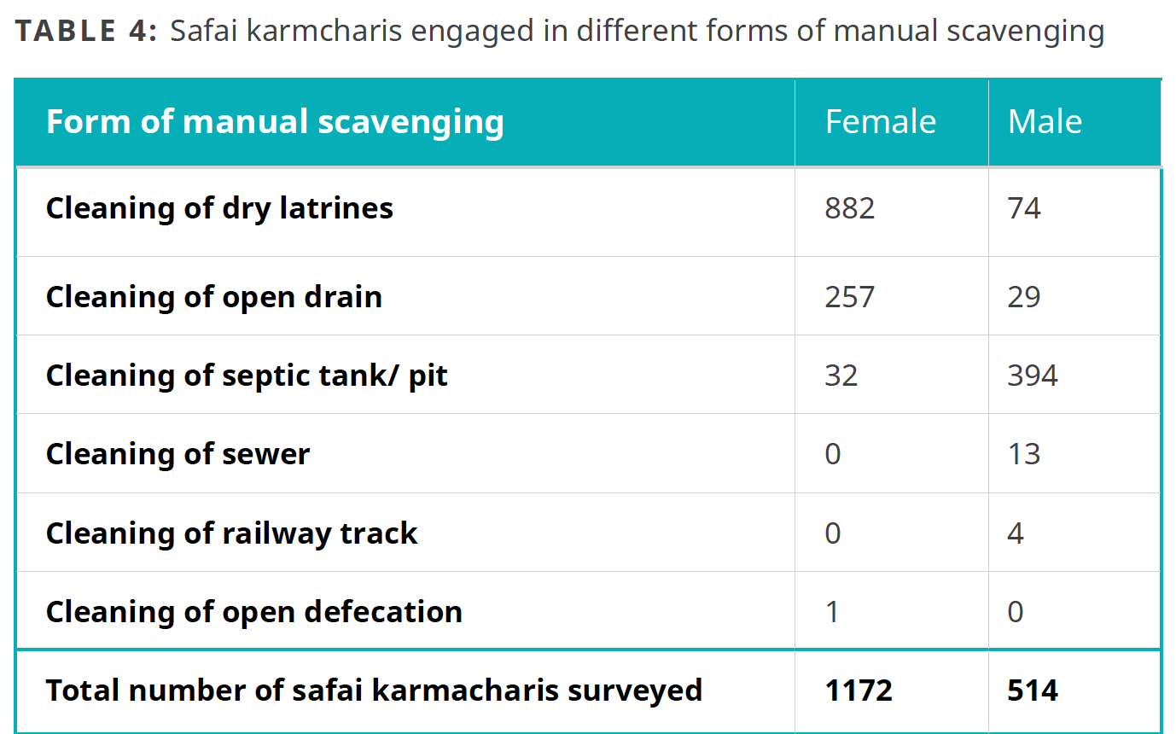

*Figure 1: Different forms of Manual Scavenging*

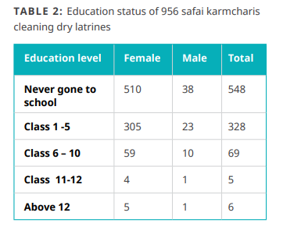

*Figure 2: Education status of manual scavengers cleaning dry latrines*

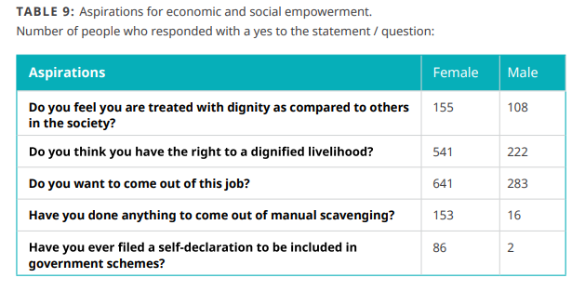

*Figure 3: Aspirations of social and economic empowerment*

**Problem Statement**

A lack of sanitary infrastructure and end-to-end services for human waste has resulted in an informal market solution that relies heavily on governance failures, market failures, and cultural status quo. The state has failed to improve sanitation infrastructure and provide the bare minimum provisions to re-employ manual scavengers who are forced to fill the gap of poor sanitary conditions in India. This discriminatory practice continues to fuel the informal market solution.

**Key Concepts on Market Failure**

Manual scavenging is persistent for several reasons, primary among them being a governance failure. In areas where sanitary infrastructure exists and is operable, their upkeep is in part being done by the dalit community, and where the systems are incomplete, the dalits fill in the gaps. In both instances the government has failed to address the issue of infrastructure creation and maintenance, and instead opted to permit the situation to resolve itself. In the absence of inadequate infrastructure, social marginalization and lack of other economic opportunities, the dalits from the scheduled caste have had to step in. This natural resolution to the crisis contributes to the paradigm that is perpetuated across most states in India.

However, the governance failure is only one of the contributing factors. The private sector of the market has also not stepped up. It has instead allowed the informal market to continue to produce a solution to the underdeveloped system that the governance structures had put into place. This hands-off approach has resulted in a notable lack of creativity in finding innovative/out of the box solutions that could remove the human requirement to do this work or at least give them tools to do the job more safely.

This perfect storm has resulted in an informal market that fails to value the labor of manual scavengers appropriately. Their labor is so undervalued that they are relegated to cleaning up the waste systems that no other entity is interested in fully managing. Since there are no other kinds of work available to this group and they need to make money to survive, their desperation allows the governance structures and market to persist, maintaining the status quo. And thus the cycle continues as before. Because this work exists beyond the formal sector, the mental and physical health repercussions are not even spoken about. The lack of social insurance for the Dalit population only deepens the problem.

If the labor of manual scavengers was valued appropriately, not only could they be granted the dignity in their work that all humans deserve, but the country could benefit from the economic gains of the appropriate valuation labor. By releasing the constraints on this group of workers and allowing them to reach into the wider market, their wellbeing and contributions to society would both be amplified.

For the purposes of our intervention we understand that the issue is a demand-side: that manual scavengers are interested in better, more humane employment, and merely lack the skills, training, and/or certification to obtain such. In this characterization of the problem the binding constraints of social exclusion and employer discrimination present significant barriers to any shift in demand-side mobility for manual scavengers. It also means that a further consideration of our intervention will be employer sensitization to change hiring attitudes.

**Theory of Change**

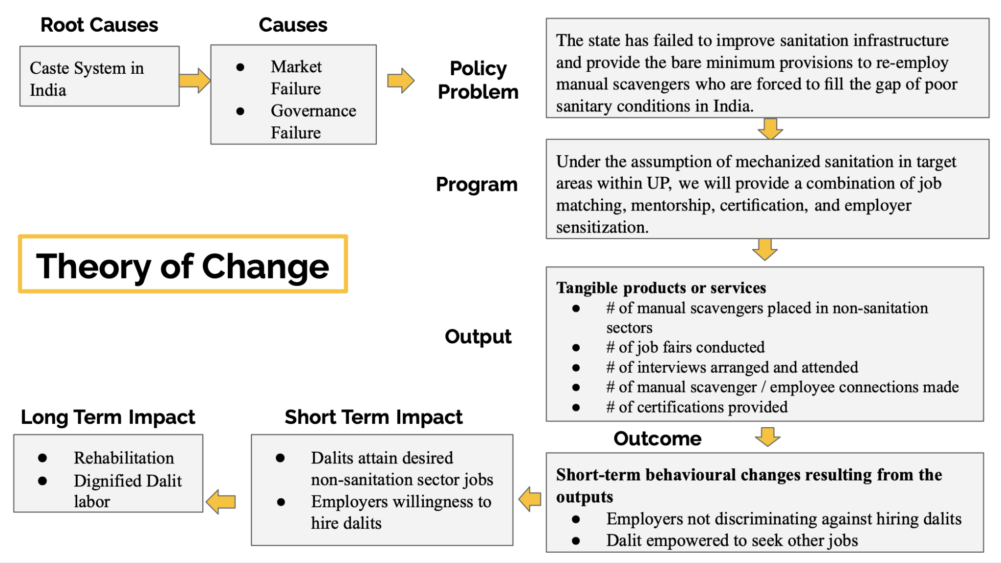

*Figure 4: Theory of Change*

**Geographic Focus**

The scope of this study will be limited to the northern state of Uttar Pradesh (UP), which is the fourth largest state in terms of area and the most populous state of India. According to official data published by the Ministry of Social Justice and Empowerment, out of the total 58,098 manual scavengers in the country, Uttar Pradesh accounts for 32,473 people. Around 347 workers died while or because of cleaning sewers and septic tanks between 2017 and 2022, of which, UP accounted for the highest number of deaths (51).

As per the National Survey 2013, 2018 National Safai Karamcharis Finance & Development, 3 districts which have the highest reported numbers of manual scavengers; Budaon (2,866), Shahjahanpur (3,391) and Farrukhabad (1,040) will be taken into account (Gaon Connection, 2022). Figure 5 shows the map of the state of Uttar Pradesh with the district-wise number of manual scavengers that are eligible for a one-time cash assistance by the government.

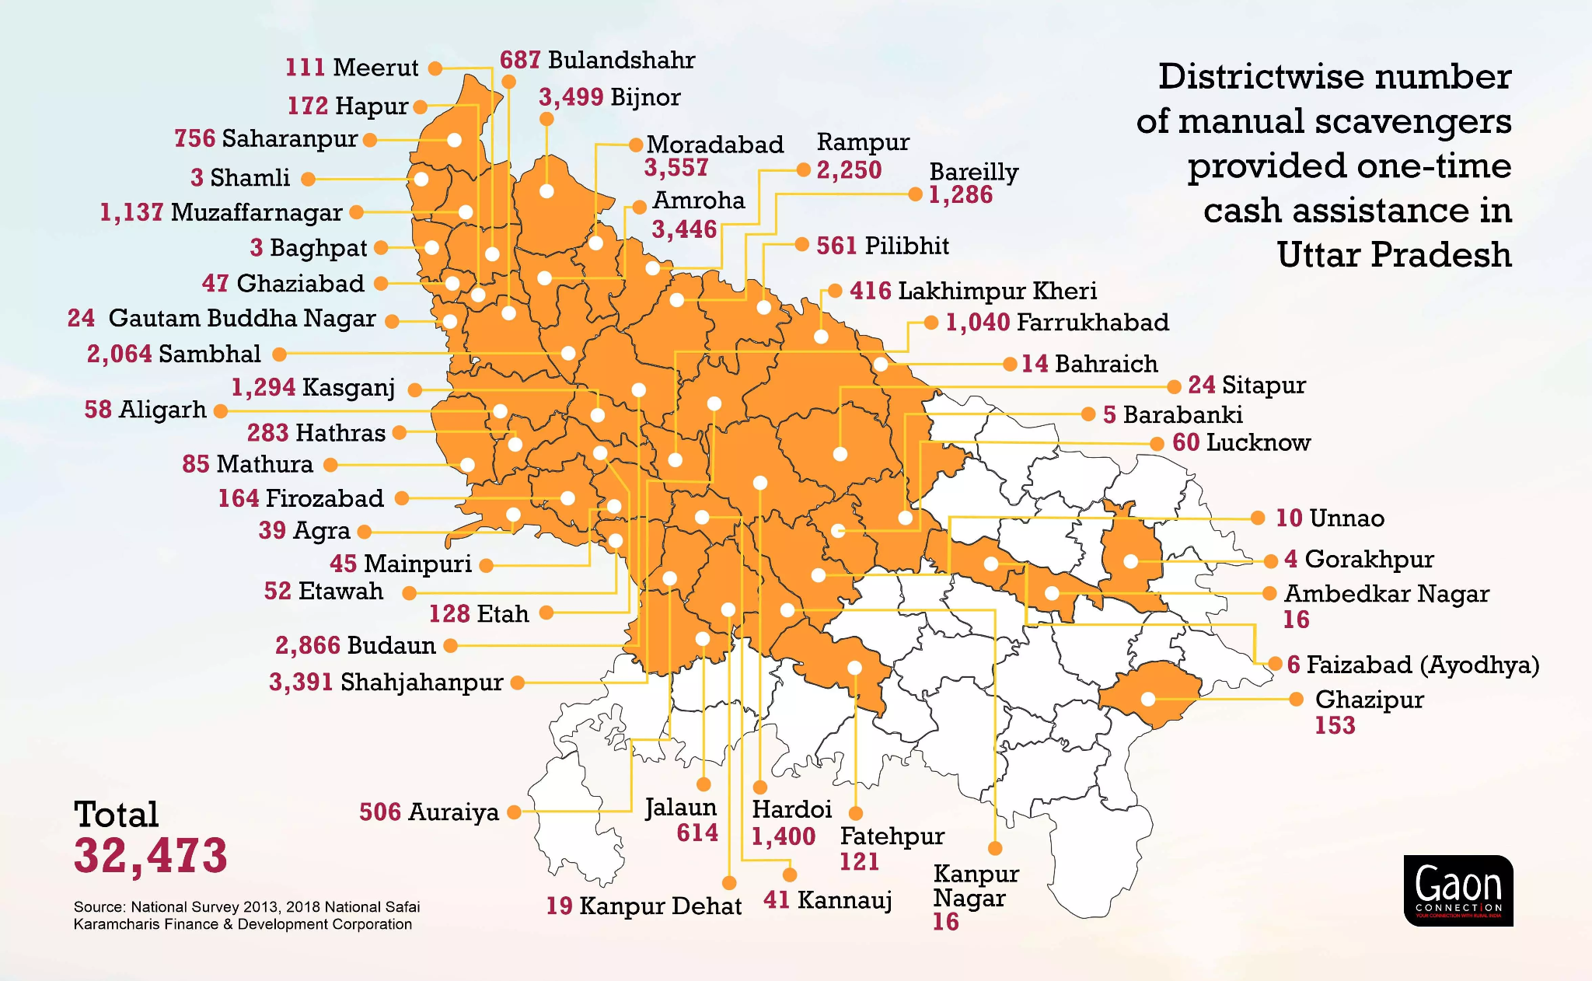

*Figure 5: District Wise number of manual scavengers provided one-time cash transfer in UP*

**Program Description**

Our intervention attempts to address the discrepancies that have contributed to the dehumanization of manual scavengers and their exploitation within the broader sanitation system. It aims to build the capacity of manual scavengers themselves in transitioning to the employment fields of their choice. As part of Budget 2023, the Finance Minister of India announced the introduction of 100% mechanization for cleaning of septic tanks and sewers across India, in addition to a one-time cash assistance (INR 40,000 or ~ USD 500) for rehabilitation of manual scavengers. However, as per some qualitative surveys, the one-time cash transfer did not reach the majority of the documented beneficiaries.

For the purpose of our study, we will exploit an exogenous change in the form of a Ministry of Social Justice and Empowerment announcement to implement the 100% mechanical desludging of septic tanks and sewers to transition from manhole to machine-hole sanitation. As this is a pilot project, we will work with the Ministry to ensure that manual scavengers of 47 villages in each of the three districts receive cash from the government (see section “Power Calculation: MSS and MDE” for details on how this number was determined). We will compare a control population in UP of manual scavengers in areas affected by this change, to treatment populations of manual scavengers receiving a combination of employment-related training/services, mentorship, and certification, vs. a treatment population receiving an equivalent cash transfer. Assessment of the various populations’ employment outcomes over time will allow us to characterize the efficacy of these re-employment initiatives against one-time cash transfers.

Because we believe that the binding constraint is social exclusion and discrimination towards manual scavengers, by employers. Scavengers lack training, networks, cultural capital (pertaining to their employment field of choice), and credibility amongst formal sector employers. Hence, a certification or ‘badge’ could signal scavengers’ worth to potential employers. The exact form and symbology of this requires further research into what will be most salient in the Indian cultural context, in addition to focus groups and discussions with employers about their attitudes towards scavengers and what would help to ameliorate them.

**Mechanisms**

Some of the testable implication of the results would include:

1. Number of workers re-assigned to new work
2. Public perception and change in number of instances of public defecation in specific areas that may be more prone to it

Implications are further discussed below. Null results would be useful in identifying the level of efficacy of the various arms, in which respect our hypotheses are:

H_0: Access to employment training, services, employment, and mentorship *will not* improve the likelihood of manual scavengers’ transitioning to the desired non-sanitation employment of their choice, subject to an exogenous mechanization of their labor.

H_1: Access to employment training, services, employment, and mentorship *will* improve the likelihood of manual scavengers’ transitioning to the desired non-sanitation employment of their choice, subject to an exogenous mechanization of their labor.

**A Cluster-Randomized Control Trial: Design and Data Collection**

We plan to perform exploratory data analysis and obtain descriptive statistics from several databases, regarding the incidence (geographical and temporal) of manual scavenging, open defecation, and other key sanitation indicators throughout areas of India with known deaths of manual scavengers, specifically in Uttar Pradesh, which has the highest (reported) incidence of manual scavenging. More specifically, we would need to know the number of desludging machinery disbursed at the village level and data on the number of beneficiaries of the one-time cash assistance provided by the government.

.

We will conduct a mixed-methods evaluation. Firstly, this will consist of quantitative evaluation, consisting of:

* Baseline survey
* Midline survey (6 months after intervention)
* Endline survey (12 months after intervention)

We propose conducting a Cluster Randomized Control Trial (RCT). Cluster RCT’s have seen increasing use in the global health field (Dron et al., 2021), and are particularly common in Water, Sanitation & Hygiene (WASH) studies. WASH interventions are typically delivered at a group level (such as the construction of a new improved well at a village, school, or neighborhood), lending themselves to the clustering approach. Cluster RCT’s also have the benefit of improved (perceived) external validity, owing from the fact that trials of interventions at the community level have a greater resemblance to a scaled intervention, in logistical terms (Dron et al., 2021), than for an individual RCT.

We will consult and work with the Ministry of Social Justice and Empowerment to decide upon the unit of randomization of sanitation mechanization within UP, likely at either the district or village level. This will be based upon the administrative level to which the funding for the desludging machines will be allocated.

The Cluster RCT will have 2 Treatment Arms and 1 Control Arm:

* Control Arm (C): (one-third of villages) Infrastructure projects happening, but we do NOT implement any intervention, i.e. we treat the location-specific government mechanization as an exogenous change
* Treatment Arm 1 (T1): (one-third of villages) In areas where sanitation mechanization is happening, we will provide some combination of job training, certification, employment services, mentorship, etc.
* Treatment Arm 2 (T2): (one-third of villages) In areas where sanitation mechanization is happening, we will provide cash transfer as compared with T1, where the cash transfer is equivalent in value to the amount spent in the 2nd arm.

These three arms would run parallel to each other, randomized at the village level. Each participating village would have a pre-provided desludging machine from the government and one third would receive T1- the training and certification, one third would receive T2- a cash equivalent to the amount spent on the training and certification (but excluding the administrative and HR costs), and finally one third would be participating in the control.

**Regression Model**

To study the impact of Treatment Arm 1 and Treatment Arm 2 in comparison to the Control Arm (C), we will use the Linear Probability Model, with the following regression equation:

| ***transition* = β0 + β1\**treat* + β2\**educ* + β3\**scav* + β4\**transit* + β5\**fem*** |
| --- |

where,

*transition* = The dependent variable i.e. the probability that manual scavengers transition from the scavenging field into non-scavenging field of work

*treat* = Job matching, mentorship, certification, employer sensitization

*educ* = Years of education

*scav* = Years to date spent working in manual scavenging field

*transit* = Door-to-door transit time to city center

*fem* = Gender (indicator, female=1)

**Power Calculations: MSS and MDE**

Initially we had wondered that given random assignment, how would we ensure that the 3 arms (2 treatments and 1 control) are balanced in relevant characteristics? How can we ensure, with a randomization at the village level, that there are no spillover effects, like knowledge transfer outside of the employment training, or transaction of cash, beyond the scope of the project that affects our results.

Our power calculations suggest the following:

* MSS (Minimum Sample Size): We assume a background transition rate (to non-scavenging occupations) of 1%. We assume in the best case that our intervention T1 increases the unconditional probability of transitioning by 20 percentage points, i.e. to a transition rate of 21%. However, there is some likelihood that the intervention will not be as successful as our prediction. Hence, we want to be conservative in the assumed increase in transition rate. For this reason, in our power calculation, we specify an increase in transition rate from 1% to 11%, i.e. an increase of 10 percentage points. Then, given cluster sizes of 15, i.e. 15 individuals selected per village cluster, **47 villages will be required for each of T1, T2, and C** (see Stata code), resulting in **141 villages in total,** i.e. **N= 2115 individuals** (N_T1 = N_T2 = N_C = 705). Hence, we will aim to recruit 2115 individuals across the 3 specified districts in Uttar Pradesh.
* MDE (Minimum Detectable Effect): We assume again a background transition rate of 1%. We assume that the Indian Ministry of Social Justice and Empowerment will supply 50 desludging machines, and assume cluster sizes of 15 individuals per village cluster. Given these assumptions, the MDE is 9.44 percentage points (see Stata code), or approximately half of our target 20 percentage point increase in transition rate.

**Key employment outcomes**

The success of the program will be measured through three main surveys taken by individuals who work as manual scavengers (see Appendix 1). These outcomes will be reported on the individual level. Given Oxford’s “rule of thumb states that <5% attrition leads to little bias, while >20% poses serious threats to validity” and that our power calculation shows that the minimum sample size should be 2115 individuals, the surveys will be administered at the baseline to 2500 manual scavenger participants (Catalogue of Bias Collaboration, 2017).

The baseline survey will be administered at month one of the project and will cover basic information collection ranging from demographic data to personal history. This will also include initial information about the individual’s interaction with the manual scavenging profession and any other work they would be interested in. Finally it will ask for self-perceived levels of wellness like food security and mental and social status. This information is critical to establish a standard by which all other information gathered at later stages, like the mid- and end-line surveys, can be compared.

Midline survey, at six months, and end-line, at one year, will include similar questions but will ask about any relevant changes that have occurred and take metrics on any efforts made toward acquiring a new position including but not limited to the number of jobs applied to, the number of activities attended, like trainings, jobs fairs, interviews, and mentoring sessions. It will also follow up on the wellness indicators noted above like how food secure and mentally/socially well-adjusted the individual feels.

**Survey Monitoring**

To monitor our surveys, we will implement the following High-Frequency Checks (HFC’s).

Check 1: Survey Timing Check

We want to characterize the most effective times during the day when enumerators obtain responses. If the check is repeated on a daily basis over a period of at least a month, patterns of responsiveness amongst the target population can be ascertained. To this end, we show results from the checks below, binning the survey start time into 1-hour intervals from 9:00-9:59 am, 10:00-10:59 am, ..., up to 5:00-5:59 pm. We define survey success, the dependent variable, as occurrences in which:

* The enumerator found the household
* Member of household was present
* Consent to perform survey obtained

We acknowledge that this assumes that surveys that were started were also completed during this enumerator visit.

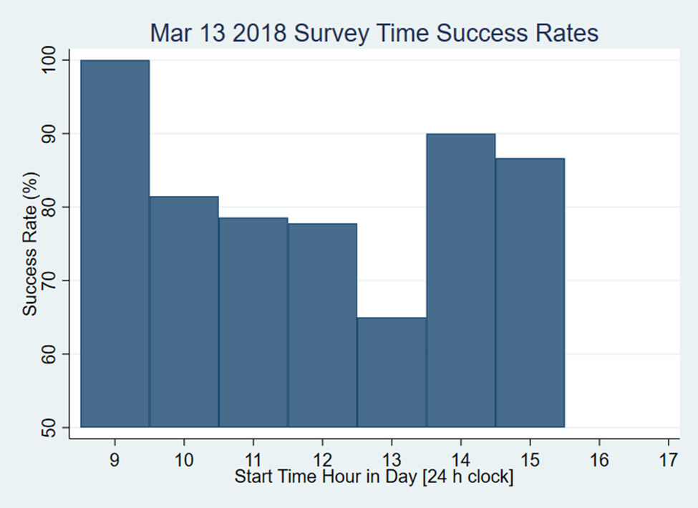

*Figure 6: Example graph depicting most and least successful times of day for enumerators to survey households, as produced by our HFC code.*   
  
Based on the graphs (e.g. Figure 6), we do not see an obvious pattern in most successful times during which to conduct surveys. This could be because we only have data for ~2 work-weeks (11 days) in this dataset, which is a small sample. If continued for a few more weeks, however, patterns may emerge, which could be used to inform the field manager of when to best schedule enumerator shifts.

Check 2: Respondent Recall Check

Our group had considered choosing to focus our HFC on verifying the accuracy of information provided by surveyed individuals. During our midline survey we anticipate asking questions about individual's commute times to work. We will test respondent recall by asking the following:

1. Continuous Variable: How long their commute had been at the time of the baseline survey?
2. Indicator Variable: If they have changed jobs between the baseline and the midline survey?
3. Continuous variable: How long is their commute time currently?

To check the validity of the answers provided by participants we will put in a check regarding these questions. If the respondent has said no to Q2 above, then their answers for Q1 and Q3 should be approximately equal (assuming they have not moved household), within a tolerance. If their answers to Q1 and Q3 are not equal, then the survey should be flagged for incorrect information or further verification. If the respondent has the same job, theoretically their commute time should be the same and any deviation from that would indicate false or inaccurate information. (This does assume that the worker is returning to the same location for work each day but we are willing to make this assumption for the purpose of this check.)

**Anticipated Concerns and Complications**

**Cost:** In terms of feasibility, cost is a primary concern for any RCT. As Cluster RCT’s are generally larger than individual RCT’s (Dron et al., 2021), they require greater financial resources.

**Cultural Considerations regarding Certification:** Our prior is that certification for the (largely) Dalit population of manual scavengers will improve their employment outcomes in non-sanitation sectors. However, the certification, if poorly or inappropriately designed, could have the potential to serve as a negative signal and further ostracize manual scavengers in the employment marketplace.

**Survey Participation:** Because manual scavenging is such a sensitive topic, and those who perform it are so severely socially marginalized, it may be very difficult, if not impossible, to obtain a large enough survey sample of scavengers willing to discuss these sensitive questions

**Further Research on Intervention Type**: As little as five years ago, Bangladesh had a similar issue with human suffering from manual scavenging in urban centers such as Dhaka. However, the country has made substantial project on the issue recently. Further research on these successes will be informative for designing our intervention and evaluation in the Indian context.

**Ethics:** The topic of manual scavenging in India is culturally sensitive, and intersects with societal and class divides, particularly with respect to caste. Any attempt to change behavior and norms must contend with these challenges.

**References**

Catalogue of Bias Collaboration, Bankhead C, Aronson JK, Nunan D. **Attrition bias**. In: Catalogue Of Bias 2017. <https://catalogofbias.org/biases/attrition-bias/>

Deutschmann, J.W., Lipscomb, M. Schechter, L., & Zhu, J. (2021). Spillovers without

Social Interactions in Urban Sanitation. Unpublished Manuscript.

Dron, L, Taljaard, M., Cheung, Y.B., Grais, R., Ford, N., Thorlund, K., Jehan, F.,

Naikmuli-Mpungu, E., Xavier, D., Bhutta, Z.A., Park., J.J.H., & Mills, E.J. (2021). The role and challenges of cluster randomised trials for global health. *The Lancet: Global Health. 9*(5). E701-E710. <https://www.thelancet.com/journals/langlo/article/PIIS2214-109X(20)30541-6/fulltext>

Gaon Connection. “Uttar Pradesh has the highest number of manual scavengers. Has their rehabilitation worked. A Ground Report.” <https://www.gaonconnection.com/news-in-english/uttar-pradesh-assembly-elections-2022-manual-scavenging-rehabilitation-dalit-sanitation-narendra-modi-employment-swachh-bharat-toilets-50414>

Guiteras, R., Levinsohn, J., & Mobarak, A.M. Encouraging sanitation investment in the

developing world: A cluster-randomized trial. *Science. 348*(6237).

DOI: 10.1126/science.aaa0491

Ministry of Social Justice & Empowerment. (2021).

<https://pib.gov.in/PressReleaseIframePage.aspx?PRID=1778858>

The Indian Express. What Nirmala Sitharaman’s push to end manual scavenging means (2023).

<https://indianexpress.com/article/cities/delhi/what-nirmala-sitharamans-push-to-end-manual-scavenging-means-8417828/>

Water Aid. Sanitation Workers: The Forgotten Frontline Workers During The COVID-19

Pandemic.

<https://www.wateraid.org/in/sites/g/files/jkxoof336/files/sanitation-workers-the-forgotten-frontline-workers-during-the-covid-19-pandemic_0.pdf>

Water Aid. Status of Women Engaged in Manual Scavenging: Report based on a Baseline survey

undertaken in 2018 in four states of India (2020)

[https://www.wateraid.org/in/sites/g/files/jkxoof336/files/status-of-women-engaged-in-m](https://www.wateraid.org/in/sites/g/files/jkxoof336/files/status-of-women-engaged-in-manual-scavenging-report-based-on-a-baseline-survey-undertaken-in-2018-in-four-states-of-india.pdf)

[Anual-scavenging-report-based-on-a-baseline-survey-undertaken-in-2018-in-four-states-o](https://www.wateraid.org/in/sites/g/files/jkxoof336/files/status-of-women-engaged-in-manual-scavenging-report-based-on-a-baseline-survey-undertaken-in-2018-in-four-states-of-india.pdf)

[f-india.pdf](https://www.wateraid.org/in/sites/g/files/jkxoof336/files/status-of-women-engaged-in-manual-scavenging-report-based-on-a-baseline-survey-undertaken-in-2018-in-four-states-of-india.pdf)

**Appendix 1: Variable List**

Variables that will be measured and assessed during the *baseline* survey (not an exhaustive list) include:

* Percentage employed in manual scavenging (defined as those who remove excreta from pit latrines, remove fecal sludge, clean storm water drains, sewers, or drainage tanks, perform waste segregation, or remove waste dropped from railway lines)
  + Time spent per week performing each of these tasks
  + Money earned (INR) per week performing each of these tasks
* Percentage of manual scavengers that would like to continue working in the sanitation sector
* Type of employment (public sector/private sector/contractual/daily wage)
* Percentage using PPE (personal protective equipment)
  + Percentage aware of the importance of PPE in health & safety terms
* Percentage aware of machinery that could be used in place of manual scavengers
* Percentage using tools required for engaging in manual scavenging work
* Percentage employed in other sanitation (non-manual scavenging) occupations
  + Self-estimation of incomes (INR)
* Percentage employed in non-sanitation occupations
  + Self-estimation of incomes (INR)
* Self-estimation of incomes (e.g. per hour, per month, etc.) when the participant is surveyed (?)
* Experience with job search in other sectors or with other employers?
  + I.e. Have you tried to seek jobs in other sectors; if so, which sectors, and what methods did you employ in your search?
* Number of manual scavengers aware of the government schemes specific to the sector (list of existing government schemes)
* Number aware of a one-time cash transfer program by the government targeted towards manual scavenging workers
* Number who actually received the aforementioned one-time cash transfer from the government
* Self-perception of whether their income is sufficient to meet their basic needs

Key outcomes that will be measured and assessed at *midline* and *endline* include:

* Percentage of trainings attended
  + For attrited participants, attempt to determine the reasons for their dropping out
  + Awareness: Number of other people whom each participant told about the program
* Number of migrant workers aware about job fairs
* Number/Percentage of job fairs attended
* Number of connections made with employers
* Criteria related to range of jobs accepted
  + Maximum commuting time in hours
  + Wages
  + Requires flexible working hours (e.g. to balance child/elder care commitments)
  + Part-time vs. full-time
* Criteria related to job search effort
  + Number of applications submitted
  + Number of interview invited to
  + Number of interviews attended
* Questions related to self-perceived food security
* Questions assessing self-perceived psychosocial health
* Questions related to change in employment status